

# DYNAMICS TMS

**Objectives:**

* PLANNING & EXECUTION Page

**Introduction:**

Planning & Execution contains all functions to book a load with a carrier, rate shop, and approve carrier fees.

# Planning & Execution

## Rate Shop

### Current Loads

The rate shop system will rate shipments using all your tariffs and carrier api connectivity (if configured) in a single solution.

To rate shop, go to the Actions tab and select *Clear All,* this will remove any data left from a previous request. You do not need to clear out the origin location if it’s always the same location. Just select Current Loads and update the data.

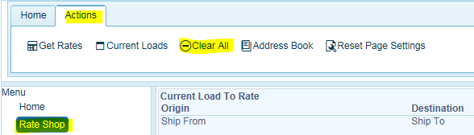

Click on Current Loads to enter in your rate shopping criteria. Yellow highlighted are required fields even if you do not have a required delivery date.

**NOTE**: In order to rate shop your carriers using the **carrier tariffs loaded in the *TMS system***, you must include the origin address location set up in TMS. You can find this by clicking on the *Address Book* for any stored origin/destination locations. Click on Open Address Book, find the origin and select the row, click Set Origin. To find the Destination address, select the row, and click Set Destination. Or just enter in destination postal code in the rate shopping screen. If you just put in the origin postal code, the system will not include tariffs that reside in the TMS database.

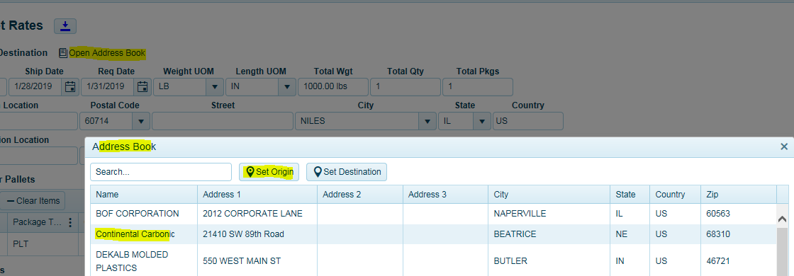

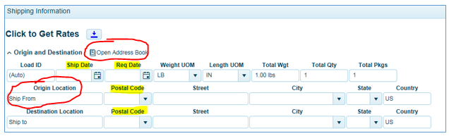

Next enter in your shipment metrics. Click on *Add Item* to fill in the required information for your rate request.

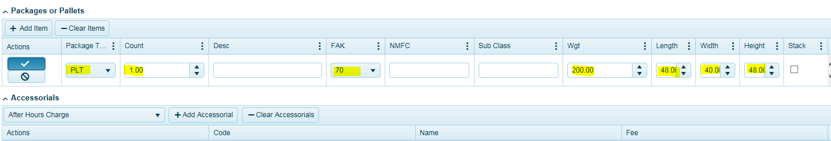

Description of goods, freight class, weight, qty, number of Plts (pallets), Package type (pallets), and dimensions of shipment. Entering in *Description of Goods* is not required for rate shopping.

If you want to add an accessorial, use the drop-down list to select your accessorial and click on *Add Accessorial*. **NOTE**: When using tariff-based carrier rates, accessorials (liftgate, appt fee) will be not be calculated as part of the estimated cost. API carriers will return accessorial charges as part of the cost estimate.

Then Click the check mark button to save your entry.

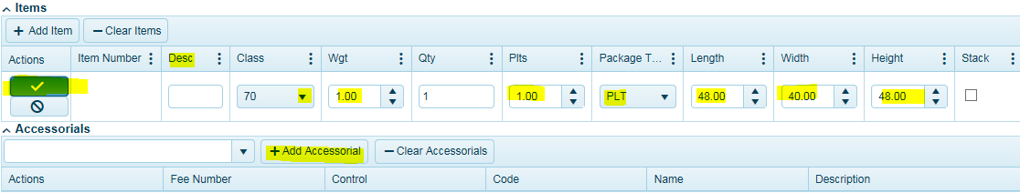

Click Get Rates button.

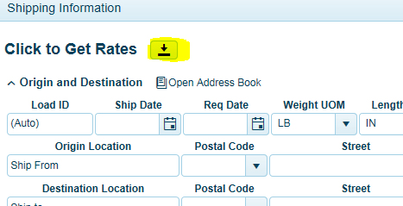

The system will return your carrier rates, quote number (if returned-not always applicable), transit times, and interline notification. Some carriers may return $0 -zero cost. This could be for a variety of reasons such as connectivity issues with API, do not service destination etc. In the Errs column, you will see a number. If greater than zero, the system returned an error message. This message can be reviewed by expanding the black arrow for that carrier and clicking on the error tab.

To eliminate from seeing zero cost quotes, use your filters to apply cost range greater than $1 - $xxxx.

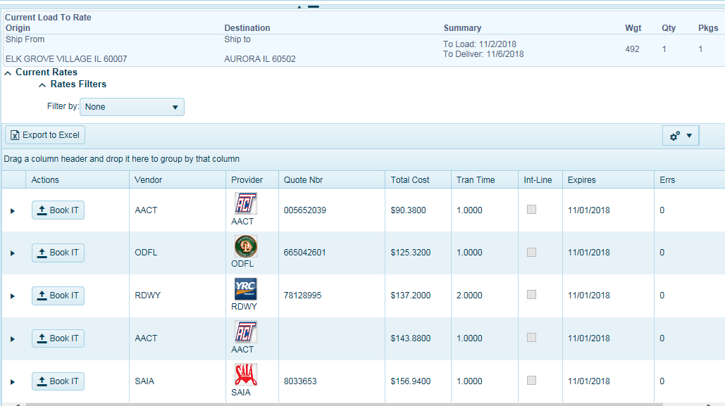

Click Clear All to start a new rate shop. Or just enter in a new destination postal code.

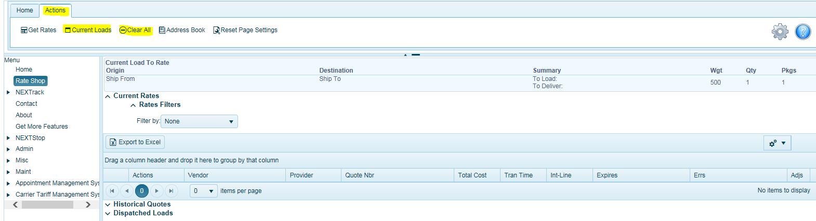

### Historical Quotes

Quotes are stored here for reference. Click and expand the black arrow to see quoted rates.

Click the Book It button to dispatch the load with carrier. Note, this is not for all configurations. See system admin for more information.

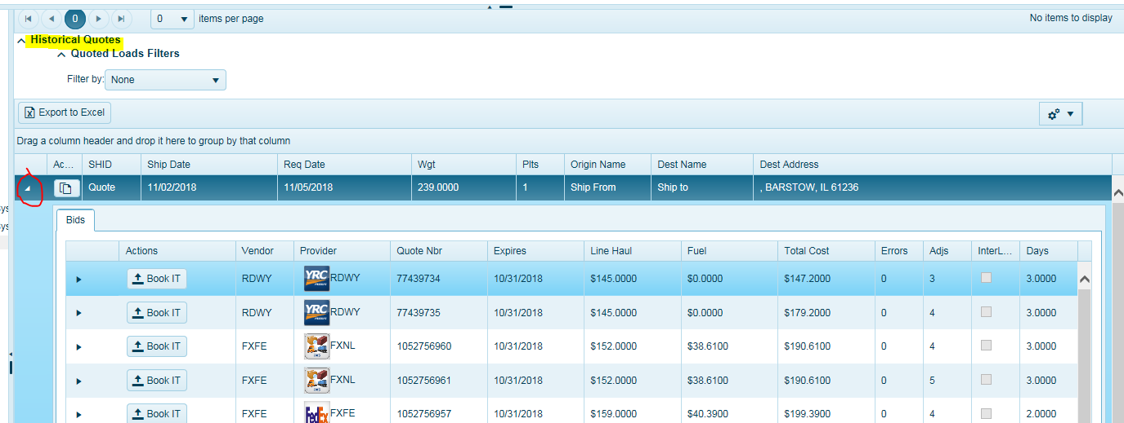

### Dispatched

Loads that have been dispatched can be viewed here. Click on the BOL button to reprint the BOL.

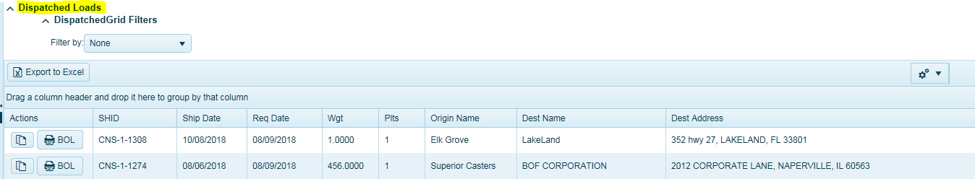

## Load Board

The Load Board is where users go to assign carriers and book loads. Users can configure their screen settings by using the field chooser selection drop down box. Simply check on the box for the data field you would like to see in your grid.   
 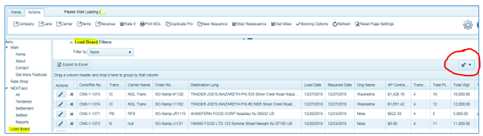

Anytime you see the settings cog, users can configure their screen settings for that page.

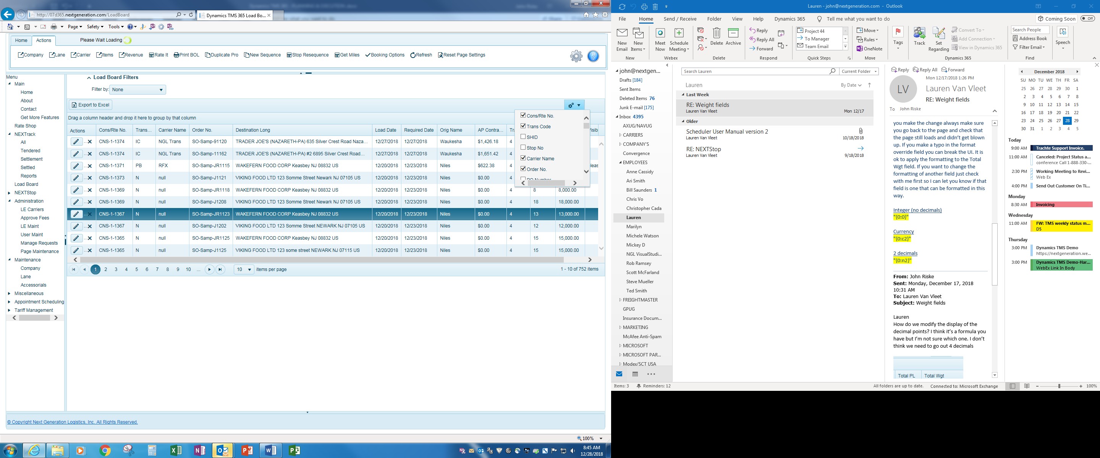

Users can organize the positioning of each field name by clicking and dragging field labels to another position and releasing when you see the double arrows.

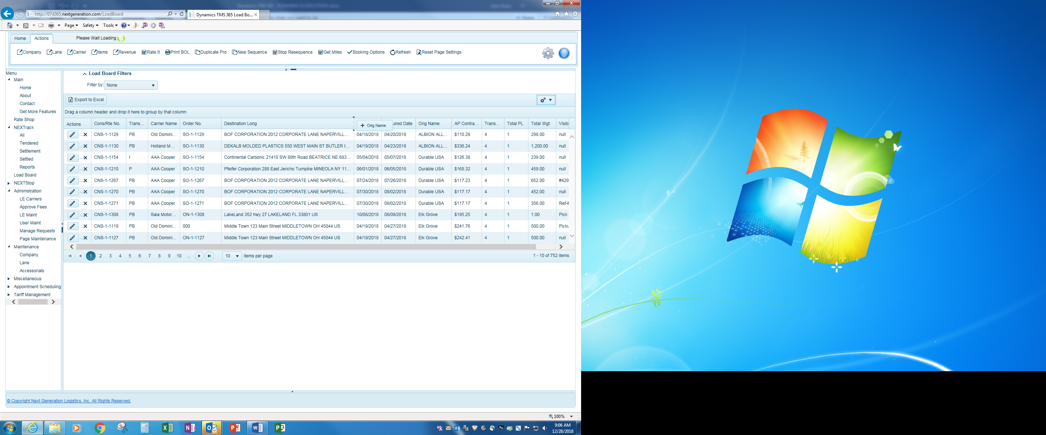

Use the Load Board Filter to easily find and sort your data.

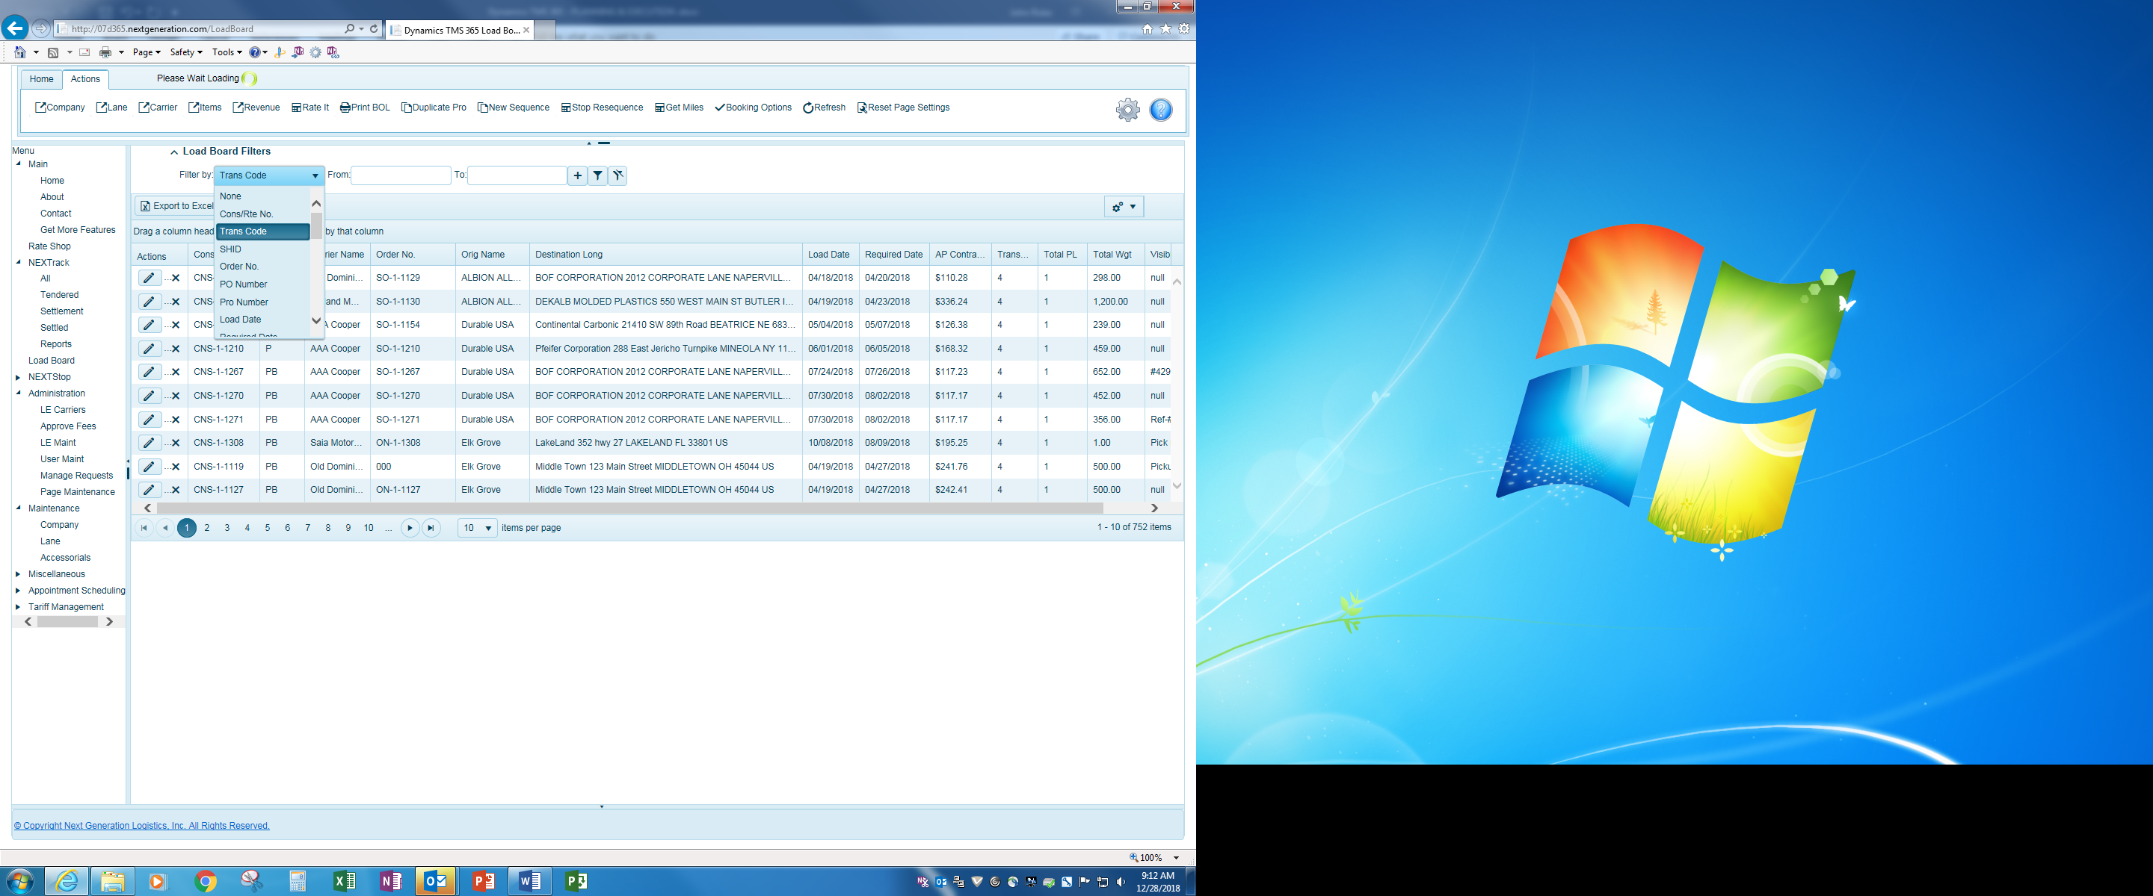

Click on the filter button retrieve data or click on remove filter to clear the filter.



### Action Menu

The action menu contains functions within the page you are on.



***Company*** = When a record is highlighted, and you click on Company (location), the system will take you the Company page.

***Lane*** = When a record is highlighted, and you click on Company, the system will take you to the Lane page.

***Carrier*** = When a record is highlighted, and you click on Carrier, the system will take you to the LE Carrier page.

***Items*** *= n/a*

***Revenue*** *=* When you click on Revenue, you will see the details of the quoted, expected, billed, pending, adjusted, and approved cost for each load.

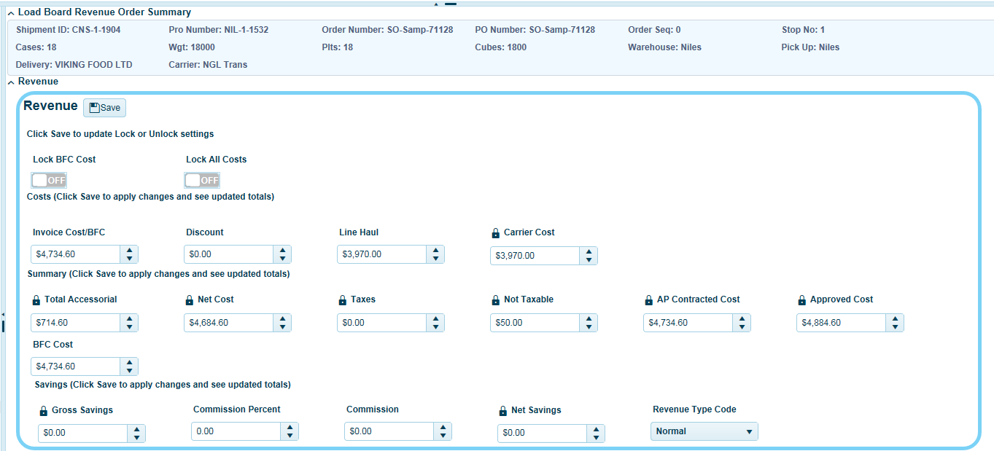

**Invoice Cost/BFC** = This field often times is set to mirror the carrier cost. BFC stands for Benchmark Freight Cost. When a value is inserted into this field, the system will auto calculate the difference (positive or negative) between the BFC and the total carrier. The Net Savings box will indicate the positive of negative cost savings.

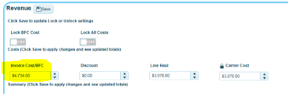

When values are added or being modified, users should turn ***ON Lock BFC Cost*** to preserve the value and prevent any automated updates to this field depending on your implementation.

You now have the ability to track and report what your quoted costs are or delivered pricing estimates by order versus the carrier cost and determined how much many was saved or lost.

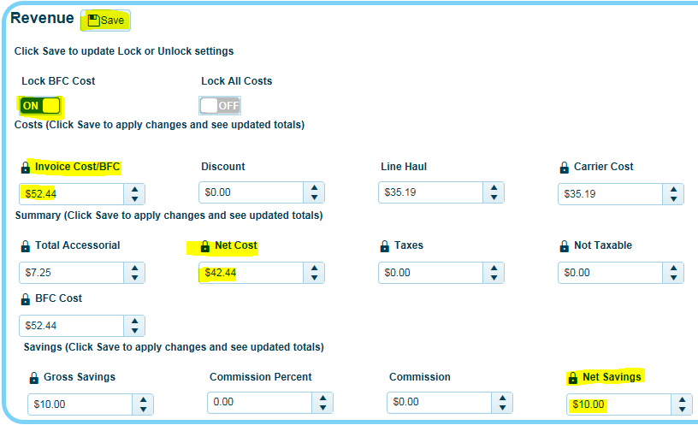

**Line Haul** = Total linehaul. Users at times may need to adjust the carrier cost following invoicing etc. When doing so, any changes made to this field, will adjust the total cost. When making changes, users are advised to turn ***ON the Lock All Costs*** to prevent any automated routines from changing this value.

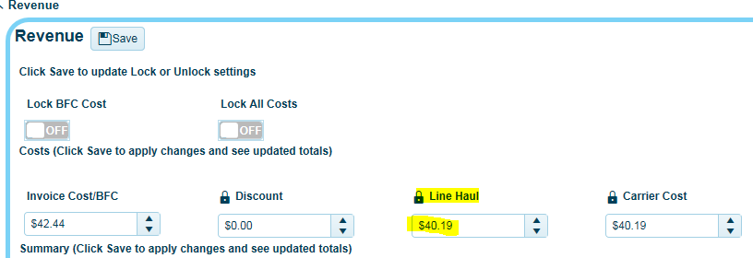

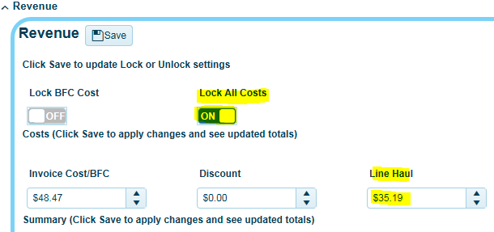

**Fees waiting for approval**.

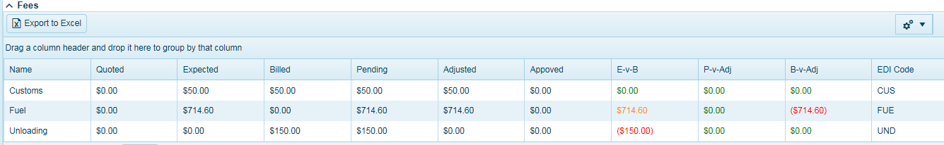

**Charges prior to approval**.

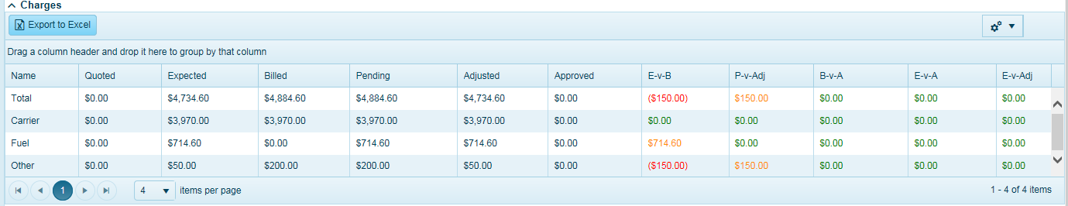

**After Freight bill has been approved**.

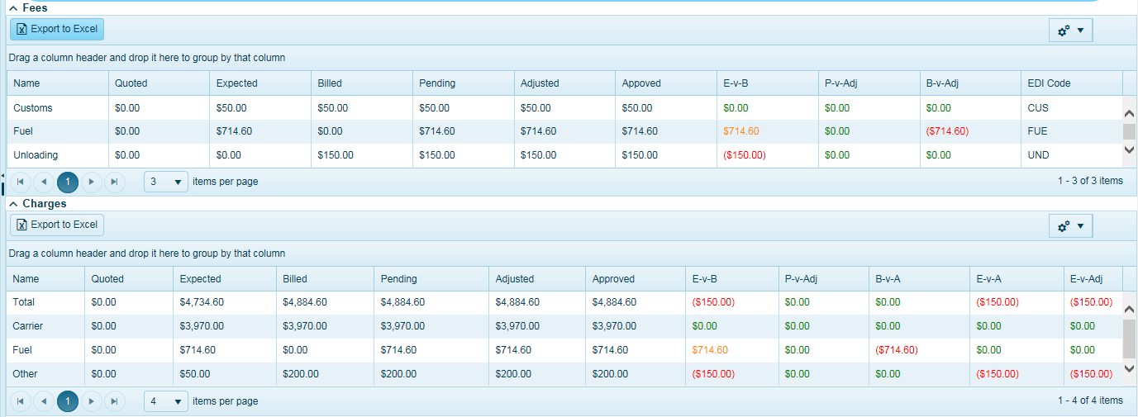

***Rate It*** = When a record is highlighted, and you click on Rate It, the system will take you to the Rating page. The Rate It page provides access to all the rating functions such as Spot Rates, Load Postings, API rating, and your Carrier Tariff rates. Only available to rate when orders are in N or P status.



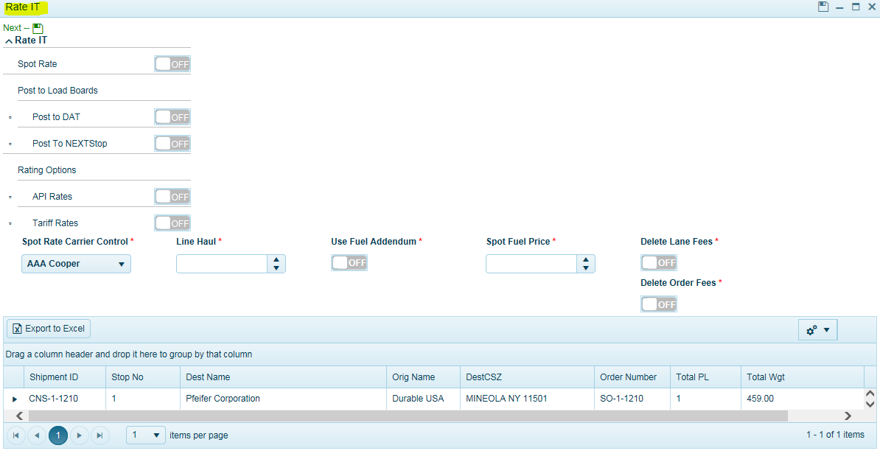

*Spot Rate* = Click ON to assign a Spot Rate for this order/load.

*Post to DAT* = External load posting. Requires additional subscription.

*Post to NEXTStop* = Internal load posting. Users can post to internal carriers via NEXTstop and allow carrier partners to bid on loads. Carriers must be set up in TMS and have been granted access.

*API Rates* = If system is configured to use carrier API’s, click ON to rate out shipment.

*Tariff Rates* = Click ON to rate out shipments using tariffs loaded into TMS system.

**Note**-Select both API and Tariff Rates if your configuration uses both API’s and the tariff system (for LTL and TL). The system will remember each user’s last selection by default.



***Change SHID*** *=* This allows users to modify the ShipID in the event of an issue when users have entered a “typo” during the PRO Number assignment. Usually, a 214 error will prompt this type of issue 24hrs after pickup.

Highlight the order in Load Board, click on Change SHID, you will see a dialog page open. The system will auto populate the fields with the current ShipID.

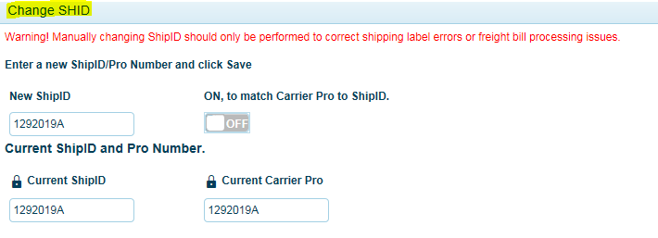

Current ShipID on the BOL.

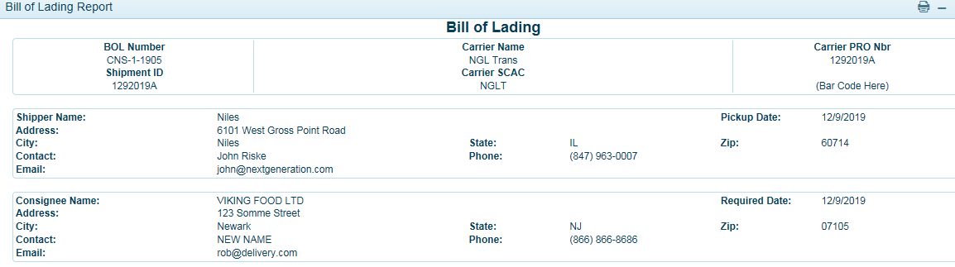

Enter in the new ShipID and **Click ON** so the ShipID matches the Carrier Pro Number.

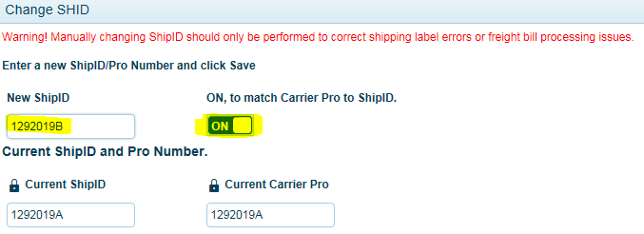

The BOL will now display the new ShipID. If required to edit the destination address, click on the pencil icon in Load Board.

***Stop Resequence*** = When a record is highlighted, and you click on Stop Resequence, the system will use PC Miler to apply the optimal stop sequence. This is for multi stop shipments.

***Get Miles*** = When a record is highlighted, and you click on Get Miles, the system will use PC Miler to apply the miles for this origin/destination pair.

***Map IT*** *= click and highlight an order, then click on Map It. The system will launch a map of the route. Additional subscription is required.*

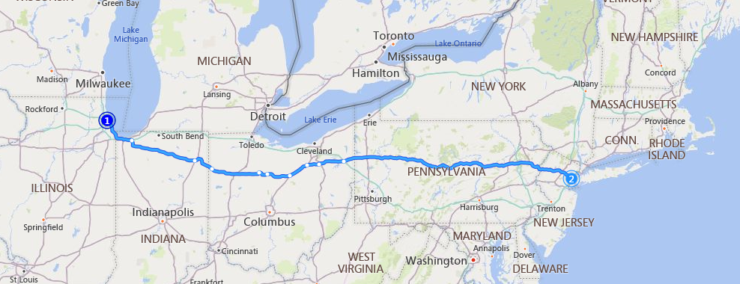

***Booking Options*** = Where users go to unassign a carrier.

*Drop Load* = Click ON to remove carrier from load and sets status back to N. Though the term   
 shows “drop” it’s also means unassigning the carrier. Note, carriers will receive an   
 email stating this load has been rejected, meaning carrier removed from taking the   
 load. It’s always good practice to follow up with your carriers on any load   
 cancellations.

Modify Load = Click ON to modify a load and brings the status to P. In this case you intend to use   
 the same carrier and will re-tender the load to the carrier. Note, the carrier will   
 receive an email (if carrier email is configured) stating this load is being modified   
 should expect an update. Users should always communicate with carrier on any   
 pickup changes.

Invoice = N/A

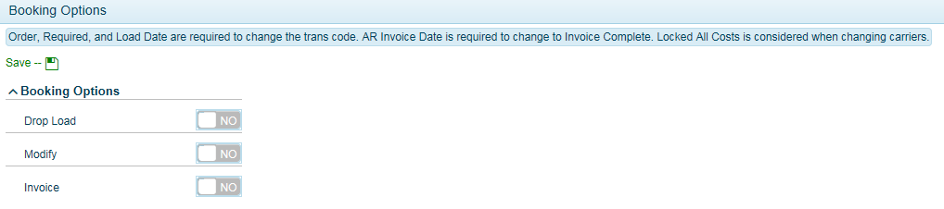

*Refresh* = click on Refresh to update the page.

*Reset Page Settings* = will reset default content and field display.

### How to Dispatch a Load - *Rate It*

In the Load Board, click and highlight the order you want to book, so it is highlighted.

Click *Rate It*

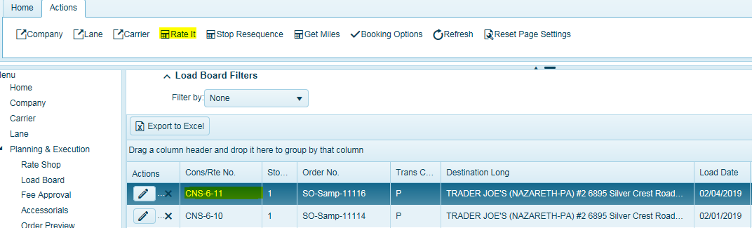

Choose your Rating Option(s)

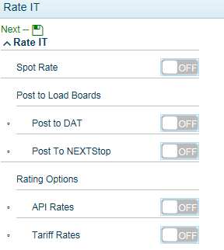

**Spot Rate** = When ON, allows user to select carrier of choice and enter in a negotiated rate from a carrier. Typically, an all-inclusive rate. Insert your line haul cost in line haul field. Turn ON to use selected carriers fuel matrix for the fuel calculation or enter in negotiated fuel price.

*Delete Lane Fees*- If lane specific fees are active on a lane, user can remove them during this process and not be part of the rate calculation.   
*Delete Order Fees* – If a user has placed an order specific fee for this order, user can remove this fee during the spot rate entry.

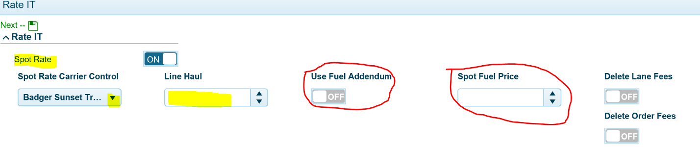

*When dispatching using a Spot Rate, the default settings for accepting loads are as follows. Users can decide how to confirm the load with the carrier.* ***ON****, to auto accept the load (PB status).* ***ON****, to send a tender confirmation email to the carrier.*

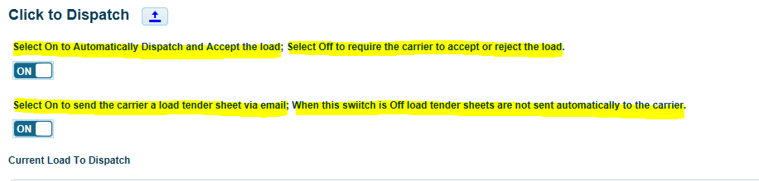

**Post to DAT** = When ON, system will post load to an external DAT load board. Additional subscription is required.



**Post to NEXTStop** = When turned **ON**, system will post a load to the portal site for all internal carriers that have been granted access to the portal, allowing carriers to enter in bids. Note, carriers must have access to portal to submit bids. No emails will be sent to any carrier about load postings. Users must manually communicate to carriers that loads have been posted if necessary.

*When posting a multi stop shipment, users should indicate in the notes the number of stops prior to posting. The system will display the final destination information and total route miles. Carriers can view the note providing they have selected this field as part of the field chooser in their screen.*

When posted, the carriers that login will see the loads in the *NEXTStop Carrier* section in the portal and TMS users will see the load posted in the *NEXTStop Ops* page. See NEXTStop Ops. Users should monitor the NEXTStop Ops page to view and aware bids.



**API Rates** = When **ON**, the system will access the carriers that are configured to use API’s for rates. When dispatched, an electronic pick up request is sent to the carrier with an automated response containing a confirmation number (pick up number). If a confirmation number is not returned for API carriers, try again as some carriers may encounter connectivity issues.

*When dispatching using API carriers, the default settings for accepting loads are as follows. You should always leave auto accept* ***ON*** *(PB Status). The default setting for sending an email is* ***OFF****. Users can determine if you would like the system to send a tender email but is not required.*

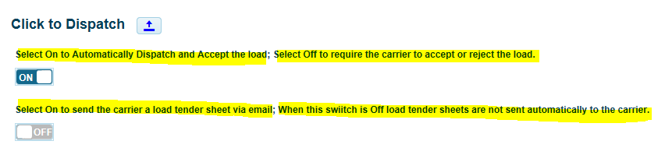

**Tariff Rates** = When **ON**, the system will access carriers that have tariffs configured in the TMS system  
**NOTE: Both API and Tariff buttons can be turned on to see all carrier rates at one time.**

*When dispatching using a tariff-based carrier, the default settings for accepting loads are as follows.* ***OFF****, to force carrier to accept load in the portal (PC-Tender Status). When On, it will auto accept and go to PB status.*

*Select* ***ON*** *and a tender email will be sent to the carrier indicating to accept load in the portal. When carrier accepts the load, it will move to PB Status. When Off, system will not send an email. Note, users can override selection based on SOP and tender/accept with carriers by going to the Booking Button and accepting the load manually.*

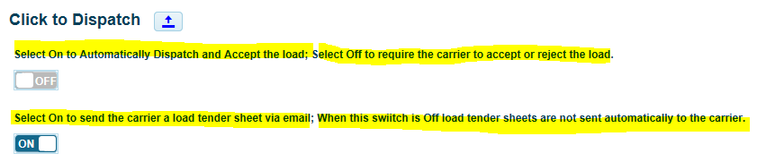

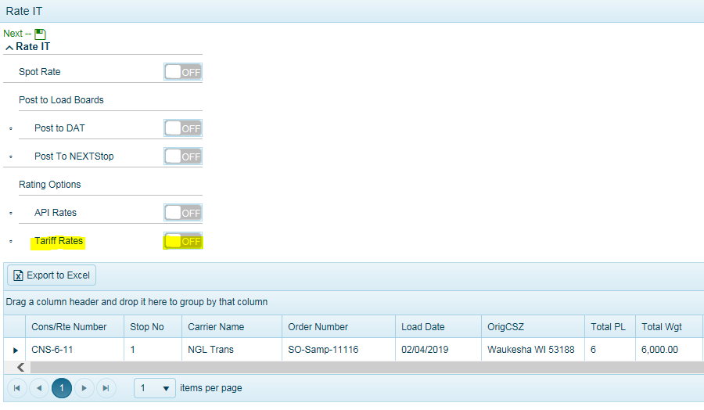

Click the black arrow to expand the details of the order.

Click the pencil icon to add/modify the package type, count, description, freight class, L x W x H, and package type. If you have configured the Package Description, the system will auto populate the description with the class that you have configured. See Tariff Document for Package Description Set Up.

Click save when done.

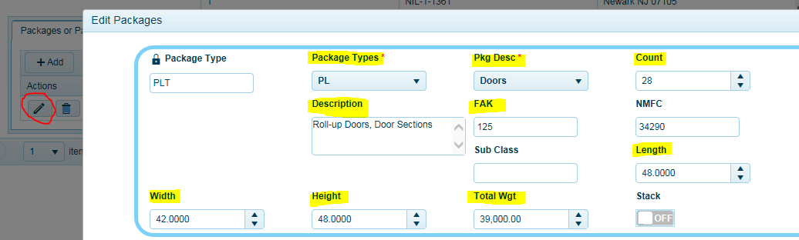

To add another pallet line, Click on *ADD* in the Packages or Pallets Tab. Update your pallets, class, dimensions, and weight. Click save.

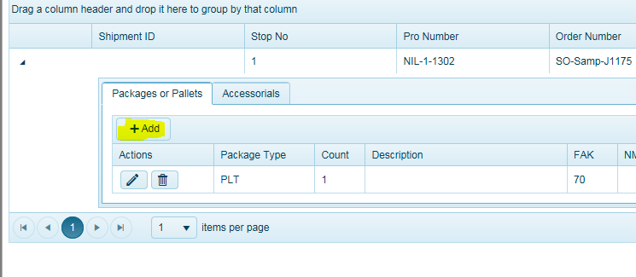

To select and assign an accessorial charge for this shipment, click on the Accessorials tab. When using API’s the system will automatically include the fee in the rate return. When using TMS tariff system, carrier accessorial fees should be set up as a profile fee to be considered in the price calculation. **The fee cost entry field will be blank by default and should only be populated if you want to override the tariff profile costs.**

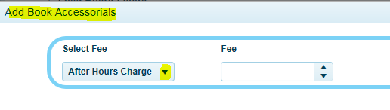

Click the green-**SAVE** it button to review rates and select carrier.

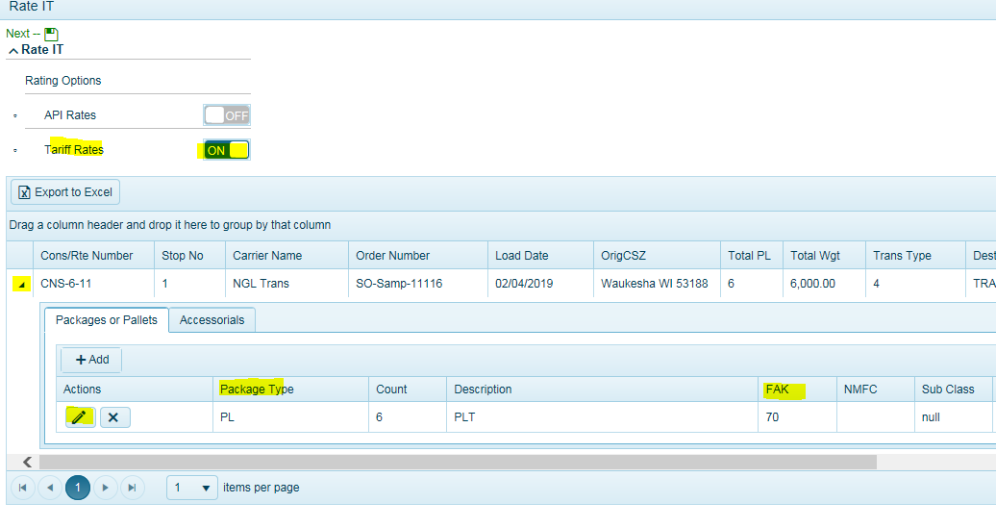

The system will return all carrier rates based on your rating options selected. This example is using the TMS tariff system and not API’s. The system will display all carrier rates for you to view and dispatch.

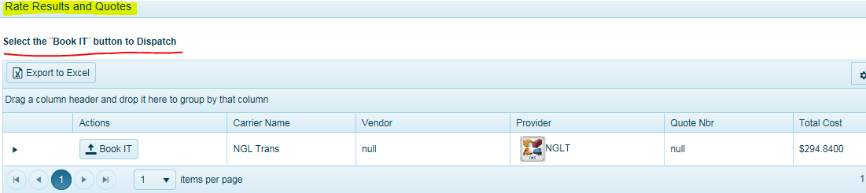

Click the *Book It* button to Dispatch this load.



The dispatch screen will populate default information. In order to dispatch, some fields are required to be populated.

Fields include:  
*Origin / Dest Contact name  
Origin / Dest Email address  
Origin / Dest Phone number*

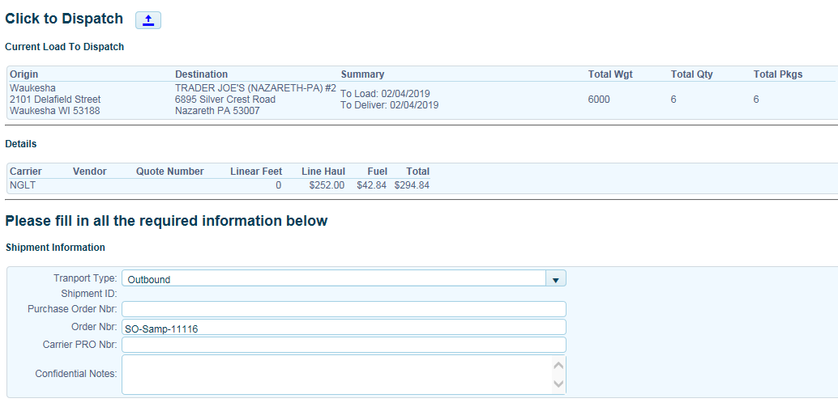

If using preassigned book of carrier pro numbers, users can insert the pro number in the Carrier PRO Number field. This will print on the BOL. **Shippers are required to apply the PRO Sticker on to the BOL.**

*If user fails to insert Pre-Assigned PRO, some carrier API’s may send back a PRO automatically. This could cause confusion upon receiving an invoice.*

In most implementations, users can populate default contact information in the Lane Page for when the next order to this particular ship to location (customer) comes in, it will auto populate.

Pick Up information

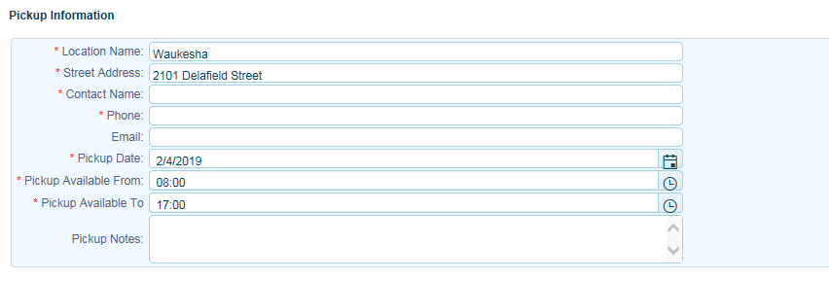

Delivery information

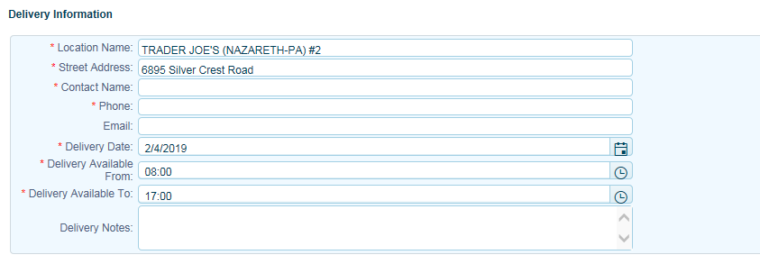

Users can set default carrier contacts to send dispatch notifications to or click on the Carrier Contact Information icon to select the correct contact.

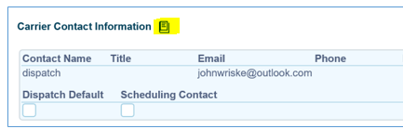

This is used when you have multiple dispatch offices and users need to send the dispatch request (email) to the correct office contact. Be sure the email address is in place in carrier contact page.

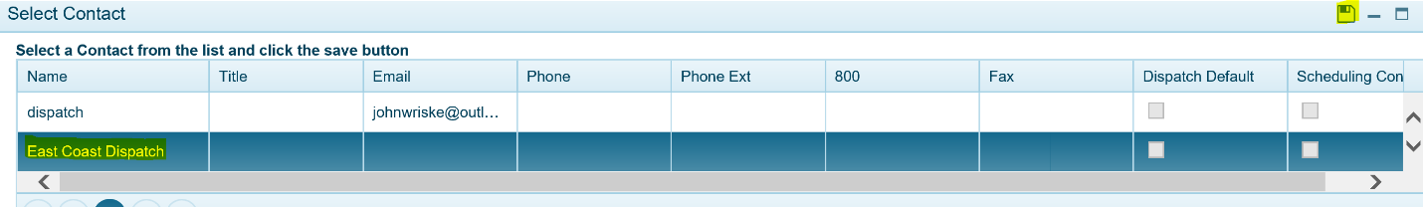

Click the Dispatch button to dispatch to carrier.

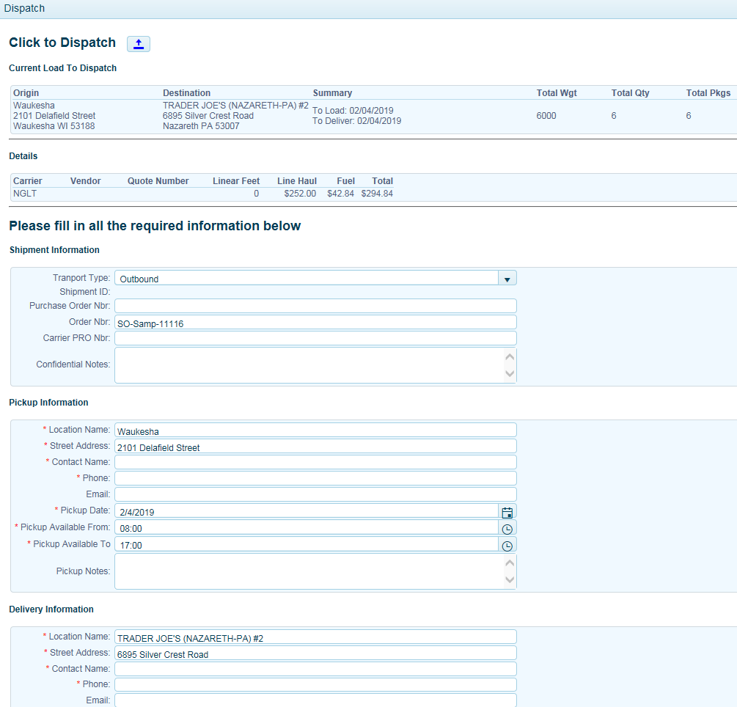

***If using LTL carrier API’s, an electronic pick up request will be sent to carrier. Carrier will automatically send a confirmation pick up number back placing the shipment Trans Code to finalized (PB) status. If no response is returned, users should try again or select another carrier.***

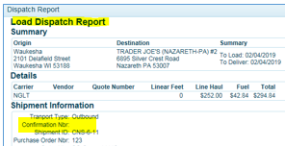

Depending on system configuration, *TMS user may have to click the Booking Options and accept the load on behalf of the carrier*, placing the shipment Trans Code in finalized status (PB). Check with support on your configuration. For example, if you web tender to carrier but carrier replies back to you in a separate email accepting the load, the user must move status to Accepted (PB) manually.

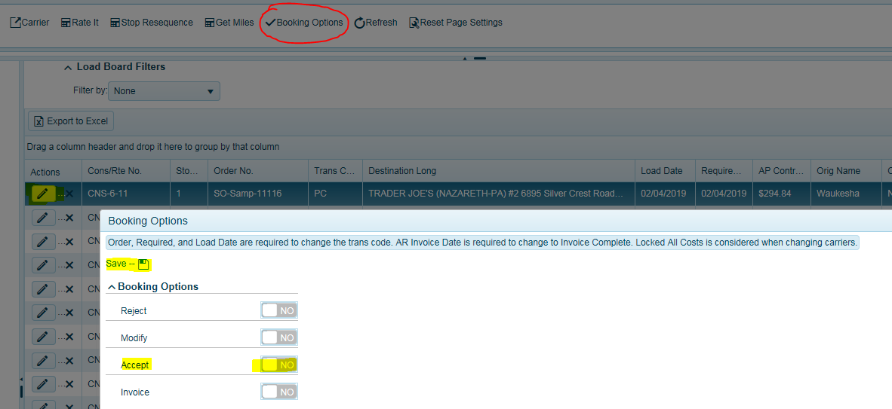

Click YES to accept load.  
Click Save.

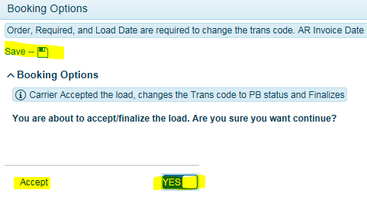

### How to Remove a Carrier from a Load

In some cases, you may need to update an order or simply remove a carrier from a load. The following options are available. This can be done by clicking and highlighting the load and going to the Booking Options button in the actions bar.

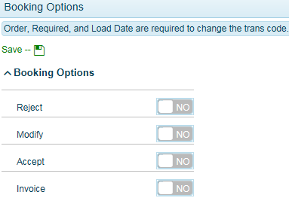

**Reject** = Carrier rejected the load and when YES, sets the Trans Code Status to **N**. Also used to remove assigned carrier from a load. If load was in PB status, this will send an email notification to carrier indicating this load was rejected/cancelled. Always best to communicate with carriers on any cancellations. If using API’s, it is recommended to contact carrier directly to cancel pick up request or follow your normal procedure for communicating with carrier. A “Load Rejection” email notification will be sent to Tariff and API carriers and should be considered cancelled. Must have carrier email set up in the email field in the carrier contact page.

**Modify** = User is modifying order and when YES, sets the Trans Code Status to **P**. An email notification will be sent to carrier indicating a modification is taken place. User should re-tender the load to carrier when done. User should confirm acceptance process with carrier based on your SOP.

**Accept** = User accepts load on behalf of carrier manually and when YES, sets the Trans Code Status to **PB**. When carriers accept load via the portal, the system will automatically move the Trans Code Status to **PB**, meaning carrier accepted the load.

Click ***SAVE*** when done.

**Note: ALL LOADS WILL NEED TO BE IN PB STATUS WHEN COMPLETE. Be sure to review all statuses as part of your process to ensure all loads are booked as required and nothing is left behind.**

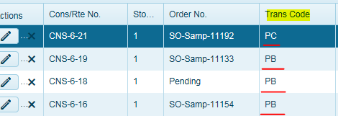

*N* = New Load (no carrier assigned)  
*P* = Carrier assigned but not booked.  
*PC* = Load has been tendered to carrier.  
*PB* = Carrier Accepted the load (Finalized).  
IC – Invoice Complete and has passed audit.

The Load Dispatch Report will print to screen. Click the print icon to print confirmation if required.

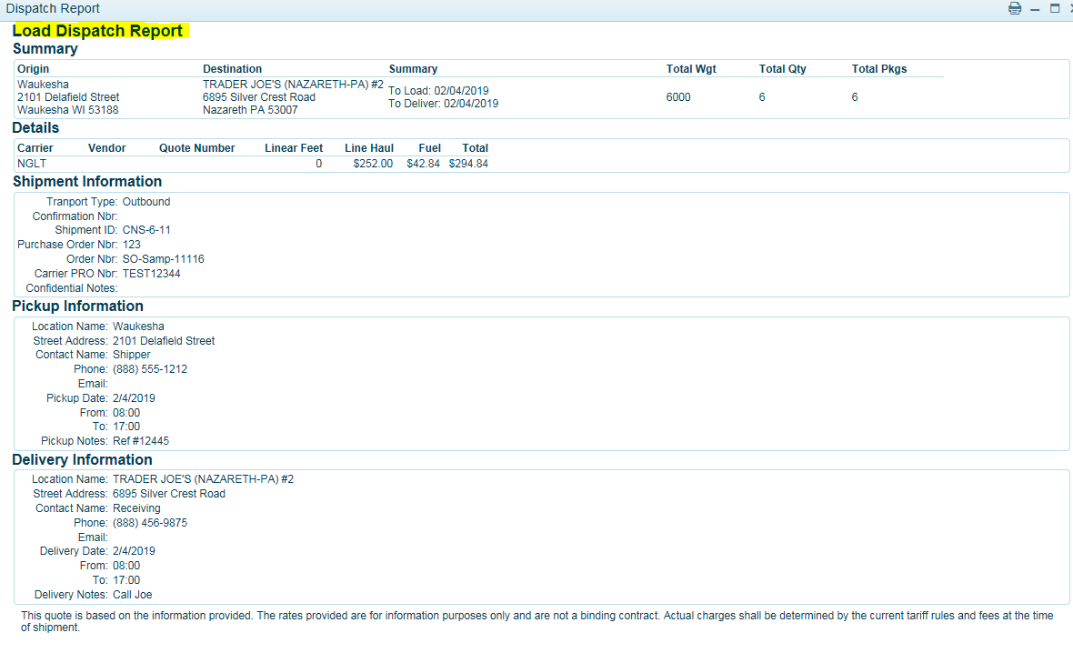

The BOL will also print to screen following the Load Dispatch Report. If you decide to print later, highlight the order and select Print BOL in the Actions Menu.

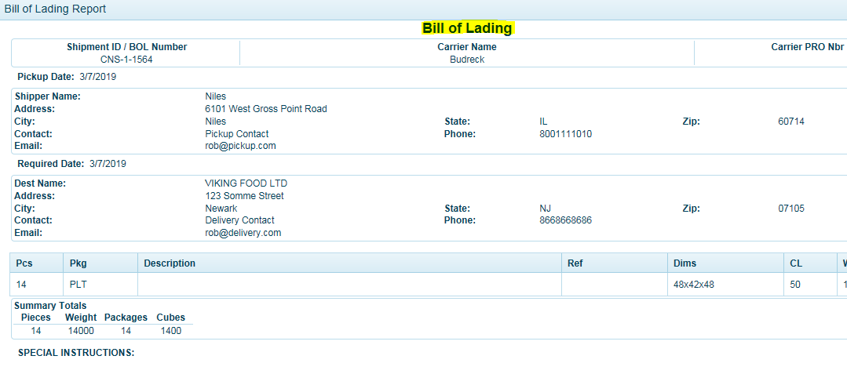

**Users should always communicate with carriers of any pickup cancellations.**

Load Board Status Codes are a two digit code in the  BookRouteFinalCode fields in the Book table.  Here is the short and long descriptions for these codes.

"SH" --> 'READY TO SHIP' -->  order is ready to ship /finalized.

"CM" --> 'BEING MODIFIED' --> order is being modified /un-finalized before scheduled ship date, may need to modify the picking data and remove the order from the load.

"NS" --> 'CHANGES POSTED' --> order has been modified/re-finalized changes are now ready for shipping.

"SC" --> 'SHIP CONFIRMED' --> order has shipped and is marked as ship confirmed.  This can occur via automated download process, via scheduled ship confirmation task or manually per order.  Various parameter flags control how and when this value is updated. The ImportAddConfirmedToPicklist parameter flag must be set to 1.

"UL" --> 'UNLOCKED AFTER SHIPPED' --> order has been unlocked and is being modified after it has shipped.

"UF" --> 'MODIFIED AFTER SHIPPED' --> order has been un-finalized after is has shipped, major changes to the order may be expected including carrier changes.

"US" --> 'UNLOCKED AFTER SHIPPED' --> order has been unlocked after is was marked as ship confirmed as least once.

"RF" --> 'REFINALIZED AFTER SHIPPED' --> order has been re-finalized and is ready to ship again after it was originally shipped then un-finalized.

"MS" --> 'MODIFIED AFTER SHIPPED' --> order has been modified after it has shipped and after it was marked as ship confirmed at least once.

"CA" --> 'CANCELED' --> order has been canceled.

### Order Preview

The Order Preview page is an exception screen that will capture all order exceptions for each warehouse location. In most implementations, this will include an order modification i.e. customer added more product to the order or date changes.

*Any order that already exists in TMS and is not booked (finalized) with a carrier the system will automatically bring in the changes into TMS.*

If the order has already been accepted and booked with a carrier (PB-Finalized) status, the order modification would come to this screen with a Warning Message *FINALIZED*. This is a warning to the user that this order already exists in the TMS and is booked with a carrier.

Another scenario would be if an order was shipping from one origin location and now customer service modifies an order to ship from a different location. The warning message would read *NEW COMP*.

NO PRO means a new order; however, most implementations are configured to bring in new orders automatically.

Users should unfinalize (by going to the Booking Options tab in Load Board) the order (PB to P) that already exists in TMS and then bring in the order modification by clicking on the black arrow. The system will recalculate the costs for the carrier assigned and users should re-dispatch the load to the carrier as necessary, so the carrier has the updated information. If using an API carrier, users should re-rate the shipment and dispatch again.

Users can apply filters by Company (location) or Trans Type (FOB Delivered or CPU’s)

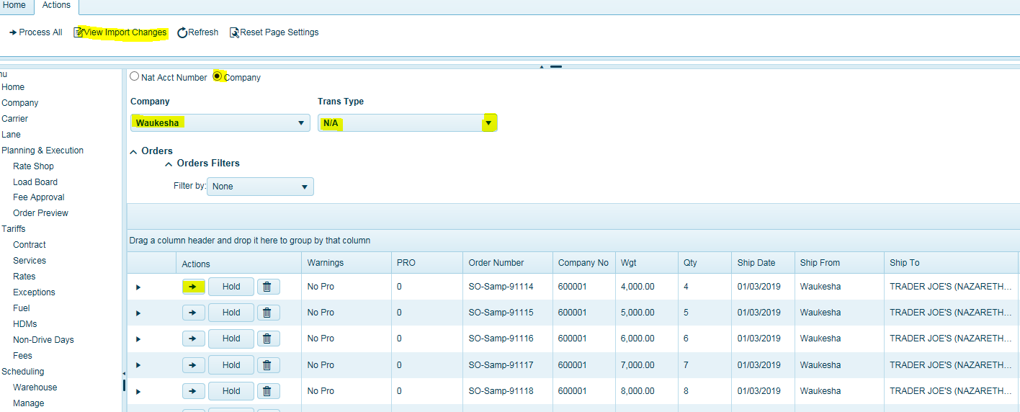

Users can click on *View Import Changes* in the Actions section to identify the specific changes to the highlighted order.

#### Warning Messages

These are warning attributes to warn the user on how to proceed with the order before importing. Some silent or auto tendered orders will get stopped in the order preview screen.

1. ***CONFIRMED***: this order is a ship confirmed update. Updates are followed by cost recalculations if costs are not locked. BFC values and Total Costs are always reallocated by weight to the item level detail every time an update is received, even if the costs are locked, this is to account for the condition where items may have changed but the total cost remains the same. An additional feature of the update process is the ability to update the pick list status upon ship confirmed. This is controlled by the global parameter “**ImportAddConfirmedToPicklist**”.
2. ***NO PRO***: this is a new order being imported for the first time. Process as normal.
3. ***DELETE-B***:  The order has been transmitted with the delete code.  It has not been accepted by the carrier, not finalized.
4. ***DELETE-F***:  the order has been transmitted with the delete code.  It has already been accepted by the carrier (finalized). The users should cancel the order with the carrier, go to booking and select Drop Load, then click on process order in order preview or delete the order from the order preview screen
5. ***DELETED***:  a matching order cannot be located in the booking table; we assume it was previously deleted.  This typically happens when we receive a ship confirmed and the order cannot be found.  There is a parameter, **GlobalTreatShipConfirmedLikeNew**, which can control this behavior.  If the parameter is on (1) the order will be marked with the No Pro attribute.  If the order is transmitted with the delete status code and the order cannot be found in the book table, the DELETED attribute will be displayed.
6. ***FINALIZED***:  a modification to the order was transmitted but the order has already been accepted by the carrier (finalized). Users should manually unfinalize the order before clicking on Process order or delete it from the Order Preview Screen if you do not want to bring in order changes. However, this will impact the order metrics and costs.
7. ***NO LANE***:  this attribute is applied with an order is transmitted and a lane cannot be located. The user should import the lane, create a lane manually; then re-transmit the order from the ERP system.  It may be possible to import the record from the order preview screen without re-transmitting, but all data must be checked for errors and this is not the recommended approach.
8. ***NEW TRAN***:  any new or modified order that is transmitted will be marked with the NEW TRAN attribute if the order data does not match the Lane Trans Type (CPU, Delivered etc..) (aka Shipment Method) or is different than the lane. It cannot be imported. Care should be taken when processing this order to be sure the correct carrier is assigned; the default carrier may not be correct. There is a company level parameter, ***PODownloadNewTranWarningFlag***, Flag to determine if records in the order preview screen are marked with New Tran if it does not match lane. Prevents silent tender. 0 = off 1 = on.
9. ***NEW TRAN-F***: this attribute is applied with a modification where The Trans type (CPU, Delivered etc..) has changed or is different than the lane after the order has been finalized.  Users can import the record from the order preview screen, but the carrier requirements may have changed, and the load should be retendered.  We suggest that you unfinalize the order before importing.
10. ***NEW COMP***:  this attribute is applied when the company/location has changed to a different warehouse. This takes precedence over NEW TRAN. Loads cannot be imported for NEW COMP automatically.
11. ***SPLIT NEW COMP***: - The ship from warehouse (company) has changed.  Users cannot import this data and it must manually be deleted from the order preview screen once manual updates are complete.  Users must manually make corrections to the existing spit loads including ship from locations and item level details.  In the case where orders were split due to capacity manual adjustment of changes to item level details is required.  One option is to delete all orders that have been split manually and re-transmit the data from the ERP system, but this is a last resort.
12. ***SPLIT NEW TRAN***: - The Trans method (CPU, Delivered etc..) has changed or is different than the lane. Users cannot import this data and it must manually be deleted from the order preview screen once manual updates are complete.  Users must manually make corrections to the existing spit loads including ship from locations and item level details.  In the case where orders were split due to capacity manual adjustment of changes to item level details is required.  One option is to delete all orders that have been split manually and re-transmit the data from the ERP system, but this is a last resort.
13. ***SPLIT ORDER***: - Users cannot import this data and it must manually be deleted from the order preview screen once manual updates are complete.  Users must manually make corrections to the existing spit loads including ship from locations and item level details.  In the case where orders were split due to capacity manual adjustment of changes to item level details is required.  One option is to delete all orders that have been split manually and re-transmit the data from the ERP system, but this is a last resort.

Below is an example of a deleted order which is an exception indicating that this order is to be deleted and it’s also assigned to a carrier- F (Finalized).

Users should un-finalize the order in TMS, notify carrier of order cancellation.

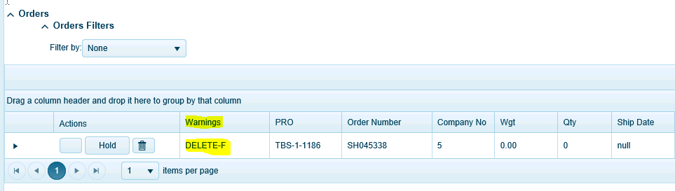

Then click the green arrow (process button) and it will delete the order in TMS.



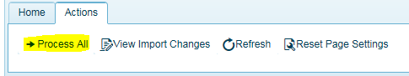

The Process All button will bring in all transactions on this page. If you wish to not bring in certain orders into TMS, users can simply place orders on HOLD by clicking the HOLD button for each record. When on hold, it will turn to RED.

